Configure Failover Routing with Amazon Route 53

Name: Ayaan Arshad

Registration No: RA2011028010070

PROCEDURE:

[https://aws.amazon.com/free/?trk=09863622-0e2a-4080-9bba-12d378e294ba&sc_channel=ps&sc_campa](https://aws.amazon.com/free/?trk=09863622-0e2a-4080-9bba-12d378e294ba&sc_channel=ps&sc_campaign=acquisition&sc_medium=ACQ-P%7CPS-GO%7CBrand%7CDesktop%7CSU%7CAWS%7CCore%7CIN%7CEN%7CText&s_kwcid=AL!4422!3!453325185010!e!!g!!aws%20free&ef_id=Cj0KCQjw_7KXBhCoARIsAPdPTfiIj_nDXTj072T5S-Pc3j6qaBSDqVs-6FJI1WtuV8Eo3mdZUwcv5_8aArdoEALw_wcB%3AG%3As&s_kwcid=AL!4422!3!453325185010!e!!g!!aws%20free&all-free-tier.sort-by=item.additionalFields.SortRank&all-free-tier.sort-order=asc&awsf.Free%20Tier%20Types=%2Aall&awsf.Free%20Tier%20Categories=%2Aall) [ign=acquisition&sc_medium=ACQ-P|PS-GO|Brand|Desktop|SU|AWS|Core|IN|EN|Text&s_kwcid=AL!44](https://aws.amazon.com/free/?trk=09863622-0e2a-4080-9bba-12d378e294ba&sc_channel=ps&sc_campaign=acquisition&sc_medium=ACQ-P%7CPS-GO%7CBrand%7CDesktop%7CSU%7CAWS%7CCore%7CIN%7CEN%7CText&s_kwcid=AL!4422!3!453325185010!e!!g!!aws%20free&ef_id=Cj0KCQjw_7KXBhCoARIsAPdPTfiIj_nDXTj072T5S-Pc3j6qaBSDqVs-6FJI1WtuV8Eo3mdZUwcv5_8aArdoEALw_wcB%3AG%3As&s_kwcid=AL!4422!3!453325185010!e!!g!!aws%20free&all-free-tier.sort-by=item.additionalFields.SortRank&all-free-tier.sort-order=asc&awsf.Free%20Tier%20Types=%2Aall&awsf.Free%20Tier%20Categories=%2Aall) [22!3!453325185010!e!!g!!aws%20free&ef_id=Cj0KCQjw_7KXBhCoARIsAPdPTfiIj_nDXTj072T5S-Pc](https://aws.amazon.com/free/?trk=09863622-0e2a-4080-9bba-12d378e294ba&sc_channel=ps&sc_campaign=acquisition&sc_medium=ACQ-P%7CPS-GO%7CBrand%7CDesktop%7CSU%7CAWS%7CCore%7CIN%7CEN%7CText&s_kwcid=AL!4422!3!453325185010!e!!g!!aws%20free&ef_id=Cj0KCQjw_7KXBhCoARIsAPdPTfiIj_nDXTj072T5S-Pc3j6qaBSDqVs-6FJI1WtuV8Eo3mdZUwcv5_8aArdoEALw_wcB%3AG%3As&s_kwcid=AL!4422!3!453325185010!e!!g!!aws%20free&all-free-tier.sort-by=item.additionalFields.SortRank&all-free-tier.sort-order=asc&awsf.Free%20Tier%20Types=%2Aall&awsf.Free%20Tier%20Categories=%2Aall) [3j6qaBSDqVs-6FJI1WtuV8Eo3mdZUwcv5_8aArdoEALw_wcB:G:s&s_kwcid=AL!4422!3!4533251850](https://aws.amazon.com/free/?trk=09863622-0e2a-4080-9bba-12d378e294ba&sc_channel=ps&sc_campaign=acquisition&sc_medium=ACQ-P%7CPS-GO%7CBrand%7CDesktop%7CSU%7CAWS%7CCore%7CIN%7CEN%7CText&s_kwcid=AL!4422!3!453325185010!e!!g!!aws%20free&ef_id=Cj0KCQjw_7KXBhCoARIsAPdPTfiIj_nDXTj072T5S-Pc3j6qaBSDqVs-6FJI1WtuV8Eo3mdZUwcv5_8aArdoEALw_wcB%3AG%3As&s_kwcid=AL!4422!3!453325185010!e!!g!!aws%20free&all-free-tier.sort-by=item.additionalFields.SortRank&all-free-tier.sort-order=asc&awsf.Free%20Tier%20Types=%2Aall&awsf.Free%20Tier%20Categories=%2Aall) [10!e!!g!!aws%20free&all-free-tier.sort-by=item.additionalFields.SortRank&all-free-tier.sort-order=asc&a](https://aws.amazon.com/free/?trk=09863622-0e2a-4080-9bba-12d378e294ba&sc_channel=ps&sc_campaign=acquisition&sc_medium=ACQ-P%7CPS-GO%7CBrand%7CDesktop%7CSU%7CAWS%7CCore%7CIN%7CEN%7CText&s_kwcid=AL!4422!3!453325185010!e!!g!!aws%20free&ef_id=Cj0KCQjw_7KXBhCoARIsAPdPTfiIj_nDXTj072T5S-Pc3j6qaBSDqVs-6FJI1WtuV8Eo3mdZUwcv5_8aArdoEALw_wcB%3AG%3As&s_kwcid=AL!4422!3!453325185010!e!!g!!aws%20free&all-free-tier.sort-by=item.additionalFields.SortRank&all-free-tier.sort-order=asc&awsf.Free%20Tier%20Types=%2Aall&awsf.Free%20Tier%20Categories=%2Aall) [wsf.Free%20Tier%20Types=*all&awsf.Free%20Tier%20Categories=*all](https://aws.amazon.com/free/?trk=09863622-0e2a-4080-9bba-12d378e294ba&sc_channel=ps&sc_campaign=acquisition&sc_medium=ACQ-P%7CPS-GO%7CBrand%7CDesktop%7CSU%7CAWS%7CCore%7CIN%7CEN%7CText&s_kwcid=AL!4422!3!453325185010!e!!g!!aws%20free&ef_id=Cj0KCQjw_7KXBhCoARIsAPdPTfiIj_nDXTj072T5S-Pc3j6qaBSDqVs-6FJI1WtuV8Eo3mdZUwcv5_8aArdoEALw_wcB%3AG%3As&s_kwcid=AL!4422!3!453325185010!e!!g!!aws%20free&all-free-tier.sort-by=item.additionalFields.SortRank&all-free-tier.sort-order=asc&awsf.Free%20Tier%20Types=%2Aall&awsf.Free%20Tier%20Categories=%2Aall)

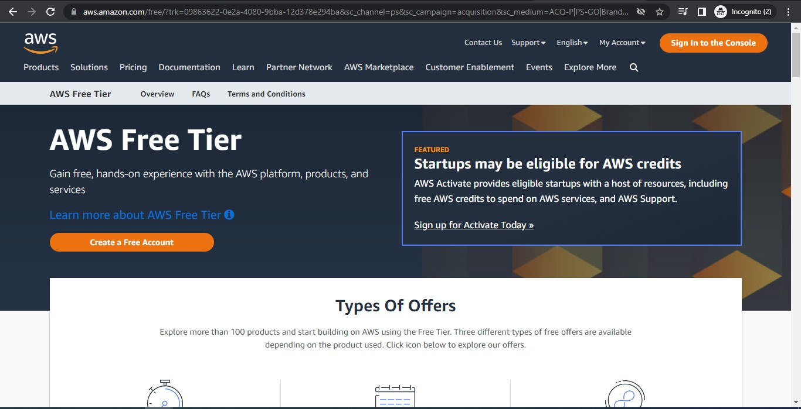

Login to your AWS account

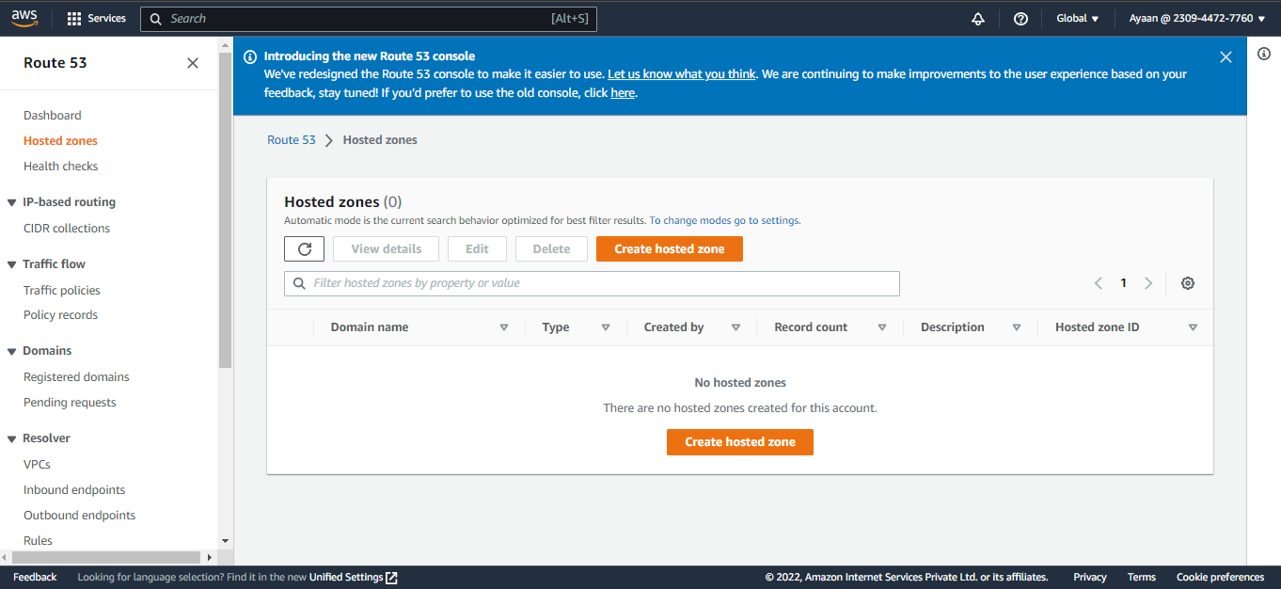

Go to Hosted zones.

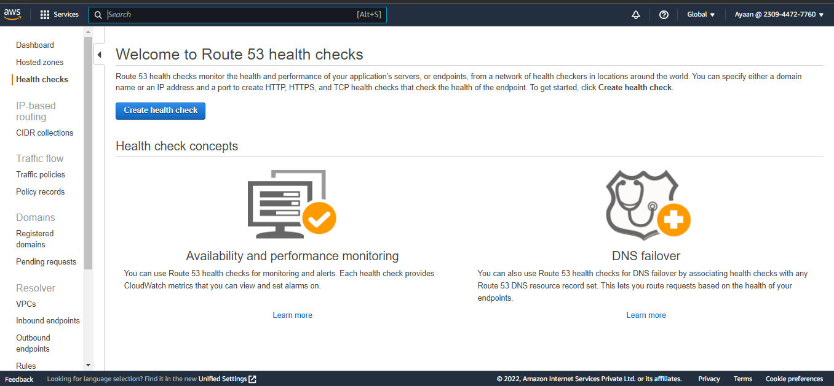

Go to health checks and create health check

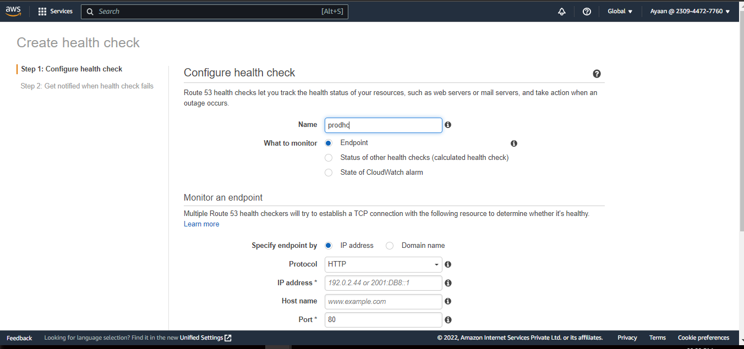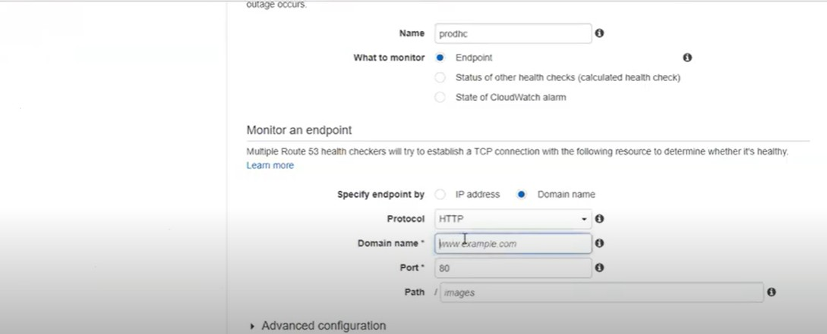Give the required details.

Give the endpoint of which you want to monitor.

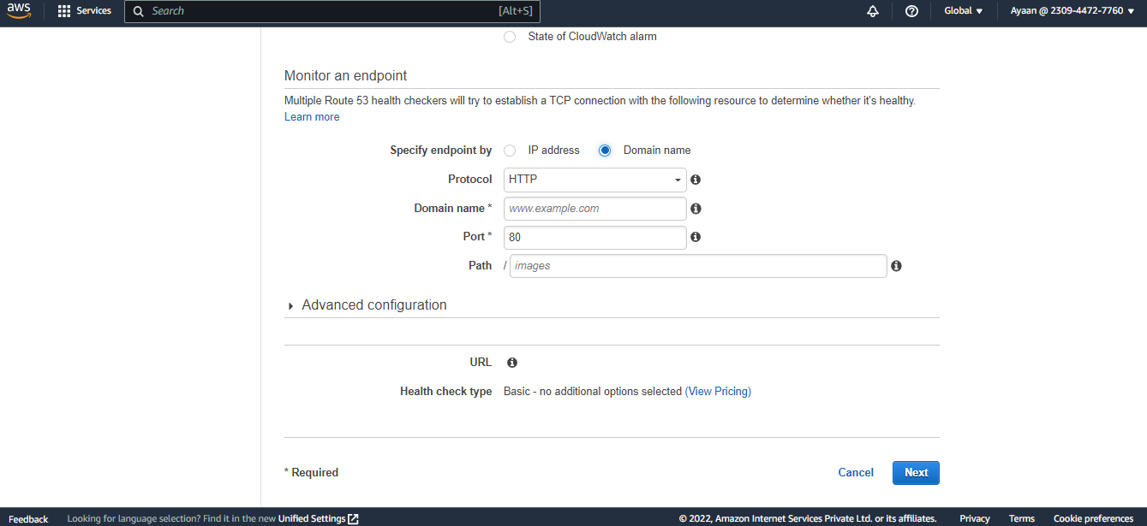Copy paste the URL in a new tab to check if it is healthy.

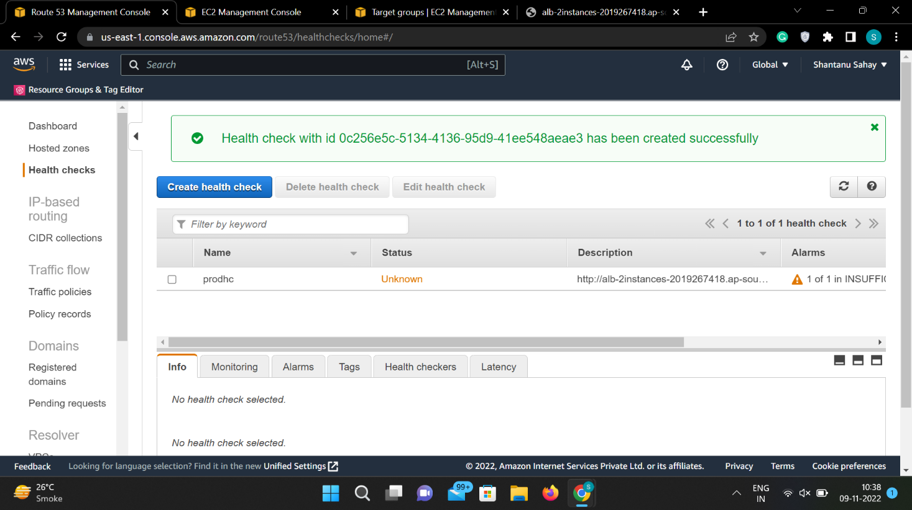If your health check fails then you can set notification and click on create health check.

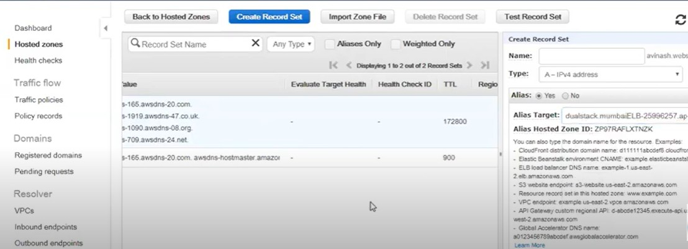Health check is created and status is unknown and soon it will turn healthy because it is healthy 8.

In the hosted zones, create a record set and give the required information with routing policy as failover and click on create.

9.

Repeat the same steps for the secondary set ID.

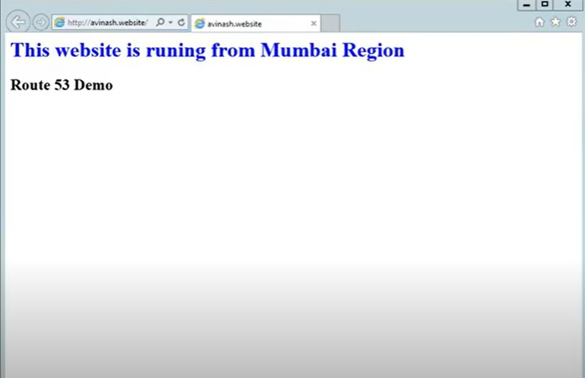10.

As it is set as primary set ID. 11.

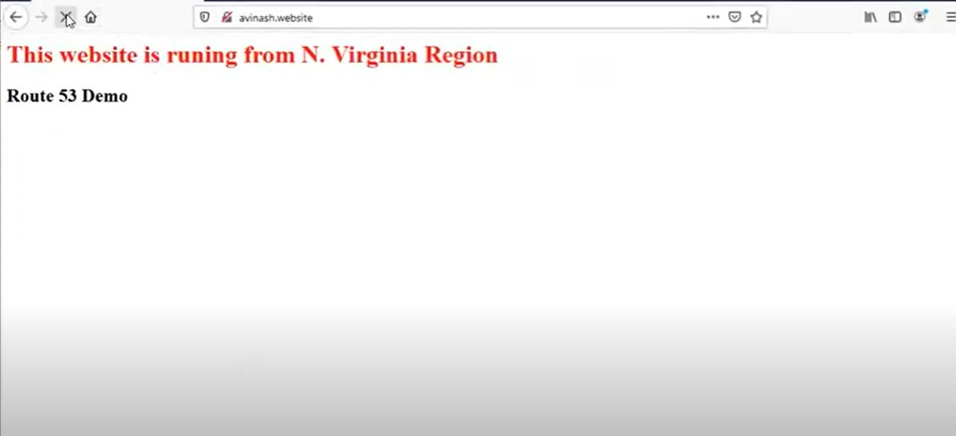

When the load on primary set ID increases it routes the traffic to secondary set ID.